PERSONAL INFORMATION | Martin Mistrik, Ph.D
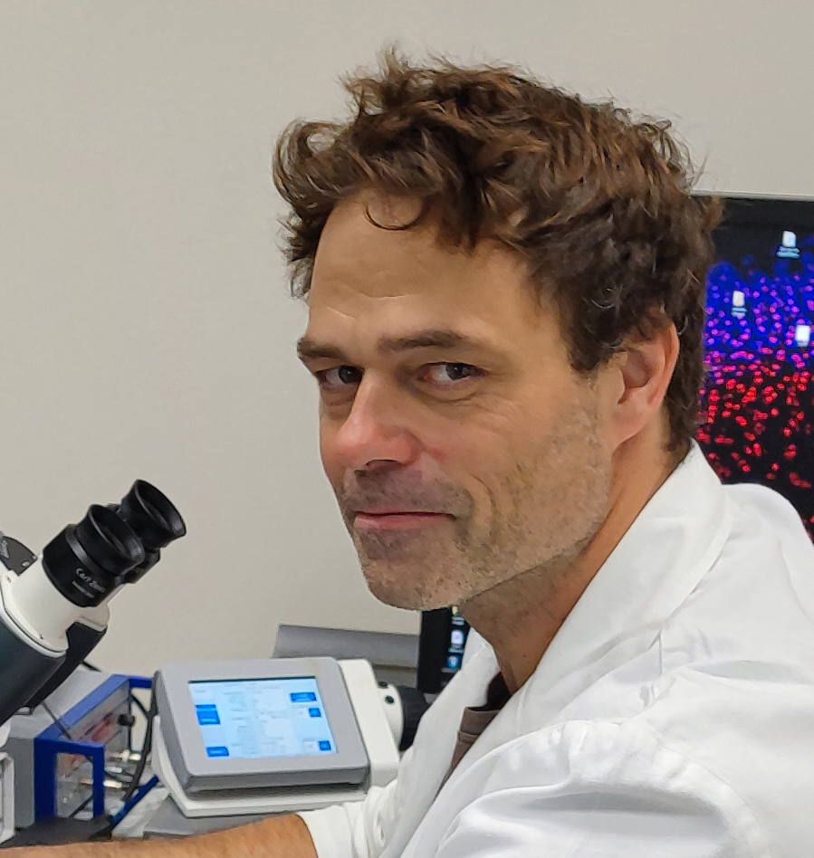 |   Za Sokolovnou 14, Olomouc, 78301, Czech Rep.

00420 585 634 873

martin.mistrik@upol.cz
 | Sex Male | Date of birth 02/08/1978 | Nationality Czech

WORK EXPERIENCE

2010 – till now  2009 – 2010 | Head of Laboratory of Genomic Integrity
2010 – till now  2009 – 2010 | Institute of Molecular and Translational Medicine (IMTM), Faculty of Medicine and Dentistry, Palacky University, Olomouc, Czech Republic  www.imtm.cz
2010 – till now  2009 – 2010 | - Senior Researcher (basic cancer research), Lab manager, Advisor of Ph.D. students
2010 – till now  2009 – 2010 | Lab Manager of Laboratory of Genomic Integrity
Laboratory of Genome Integrity, Faculty of Science, Palacky University, Olomouc, Czech Republic
www.upol.cz
 | - Junior Researcher (basic cancer research), Lab manager, Advisor of Ph.D. students

EDUCATION AND TRAINING

2005 - 2009  2005- 2005  2005- 2008 | Postgraduate study of biochemistry
2005 - 2009  2005- 2005  2005- 2008 | Department of Biochemistry, Faculty of Science, Palacky University, Olomouc, Czech Republic  Ph.D. title  Thesis: Evolutionary role of common fragile sites in human genome and mechanism of their expression  Undergraduate study of biology and nature protection  Faculty of Science, Palacky University, Olomouc, Czech Republic  Master of Science, MSc. title
2005 - 2009  2005- 2005  2005- 2008 | Training / Intership  Institute of Cancer Biology and Centre for Genotoxic Stress Research, Danish Cancer Society, Strandboulevarden 49, DK-2100 Copenhagen, Denmark  www.cancer.dk/research  Under the supervision of prof. Jiri Bartek  Research in the field of genomic instability, cellular stress pathways and cancer

PERSONAL SKILLS

Mother tongue(s) | Czech
Other language(s) | UNDERSTANDING |  | SPEAKING |  | WRITING
Other language(s) | Listening | Reading | Spoken interaction | Spoken production
English | Enter level | Enter level | Enter level | Enter level | Enter level
 | C2 C2 C2 C2 C2
German | Enter level | Enter level | Enter level | Enter level | Enter level
 | B1 B1 B1 A2 A2
Levels: A1/A2: Basic user - B1/B2: Independent user - C1/C2 Proficient user
Common European Framework of Reference for Languages

Organisational / managerial skills | Lab manager and head of the Laboratory of Genomic Integrity (employing ten people) for more than ten years. Responsible for the year’s budget approx. 300 000 Euro

Job-related skills | Specialization in advanced microscopic techniques, including fluorescence microscopy, super-resolution microscopy, laser micro-irradiations, and FRAP.

Driving licence | B

ADDITIONAL INFORMATION

Publications  H-Index  Citations | Author/co-author of more than 40 original investigations and four international patents  23  More than 3000, according to WOS

SELECTED PUBLICATIONS
Cell Death Dis. 2022 Mar 4;13(3):203. doi: 10.1038/s41419-022-04651-w
Nat Commun. 2021 Jan 29;12(1):713. doi: 10.1038/s41467-021-20989-9.#
Nature. 2017 Dec 14;552(7684):194-199. doi: 10.1038/nature25016. Epub 2017 Dec 6.
Nat Protoc. 2015 Aug;10(8):1248-63. doi: 10.1038/nprot.2015.083. Epub 2015 Jul 23.
Nature. 2015 May 28;521(7553):541-544. doi: 10.1038/nature14328. Epub 2015 Mar 23.
Cell. 2014 Jul 31;158(3):633-46. doi: 10.1016/j.cell.2014.05.046.
Nature. 2007 Nov 22;450(7169):509-14. doi: 10.1038/nature06337. Epub 2007 Oct 28.

